CMDApp — Help Manual
ConcreteInfo · Generated 08-10-2026

Getting Started
Sign in, verify your email, complete your profile, and you are on the dashboard. Everything downstream — designs, batches, tests, reports — flows from this one setup.
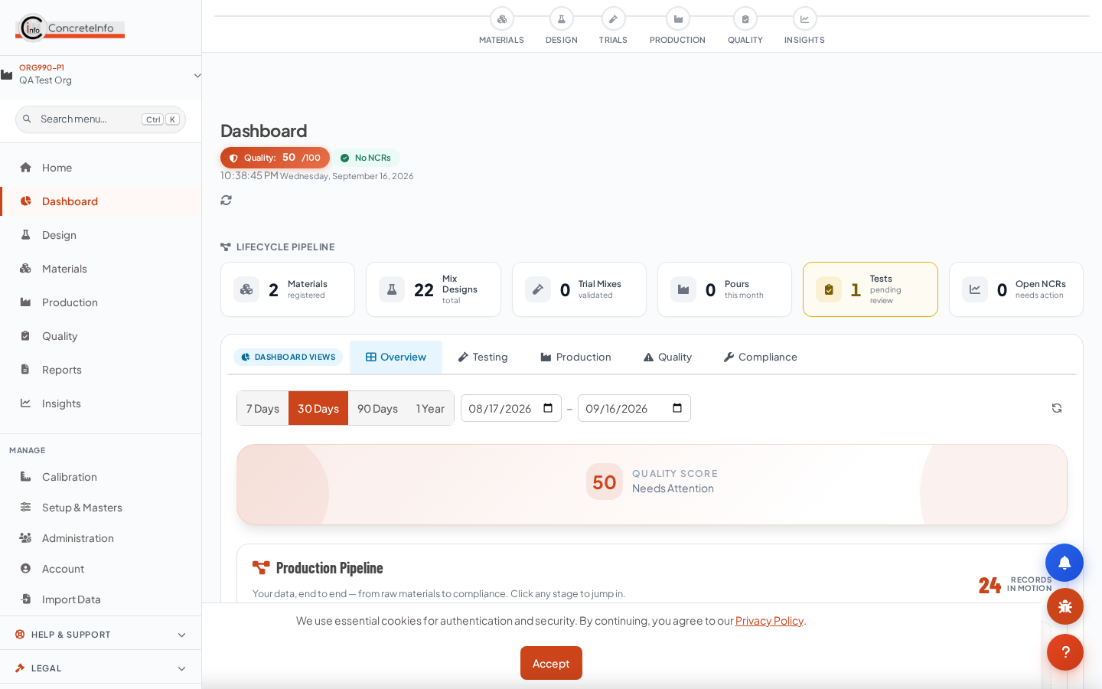
The dashboard: plant context, KPI cards and quick actions.
1. Sign in with email + password, or Continue with Google / LinkedIn.
2. Verify your email — the verification link in your welcome mail is mandatory; the app blocks everything else until done.
3. Complete your profile — phone, organisation, designation, country. This gate cannot be skipped the first time.
4. Your plant and organisation context is set automatically; switch plants from the header if you manage several.
💡 On mobile the same features appear in the bottom navigation — CMDApp is mobile-first; 80% of users work from a phone.

Your Plan & Plants
Solo (1 plant), Growth (2–4 plants) and Enterprise (5+) plans are per user per month + GST. Annual billing gives 12 months for the price of 10.
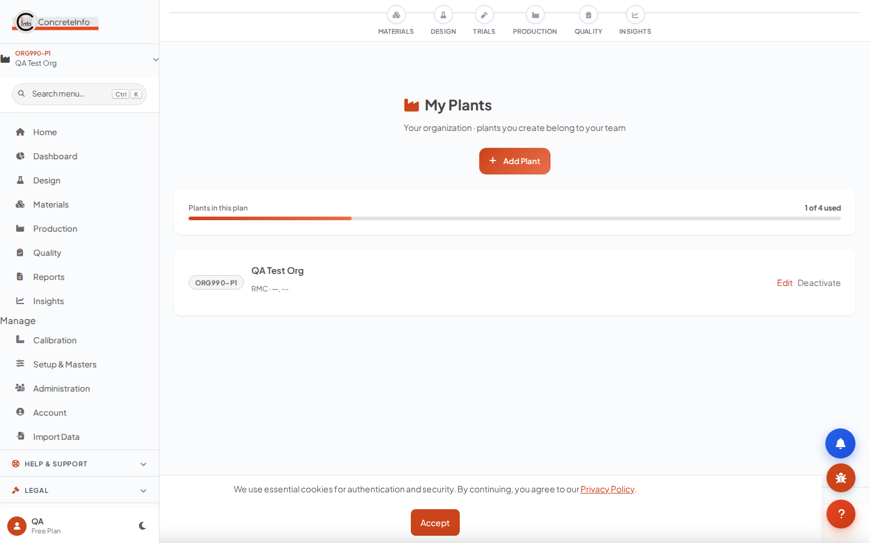
My Plants: tree view, tier meter and self-serve creation.
1. Open My Plants (sidebar → Setup) to see your plant tree and tier meter.
2. Click Add Plant, fill name/code/location — a default plant is provisioned automatically on first subscription.
3. At your tier limit the meter turns amber and the button becomes Upgrade.
Plan | Plants | Monthly | Annual (pay 10, use 12)
Solo | 1 | ₹1,299 + GST | ₹12,990 + GST
Growth | 2–4 | ₹1,899 + GST | ₹18,990 + GST
Enterprise | 5+ | ₹2,799 + GST | ₹27,990 + GST

💡 Every module — all mix-design methods, testing, analysis, exports, branding — is included in every paid tier. Higher tiers add plants, seats and storage, not features.

Standard RMC Property Form (Spec Defaults)
Define the concrete specification once per plant / customer / project. Every calculator then pulls it automatically — grade, exposure, w/c limit, cement minimum, slump, aggregate size.
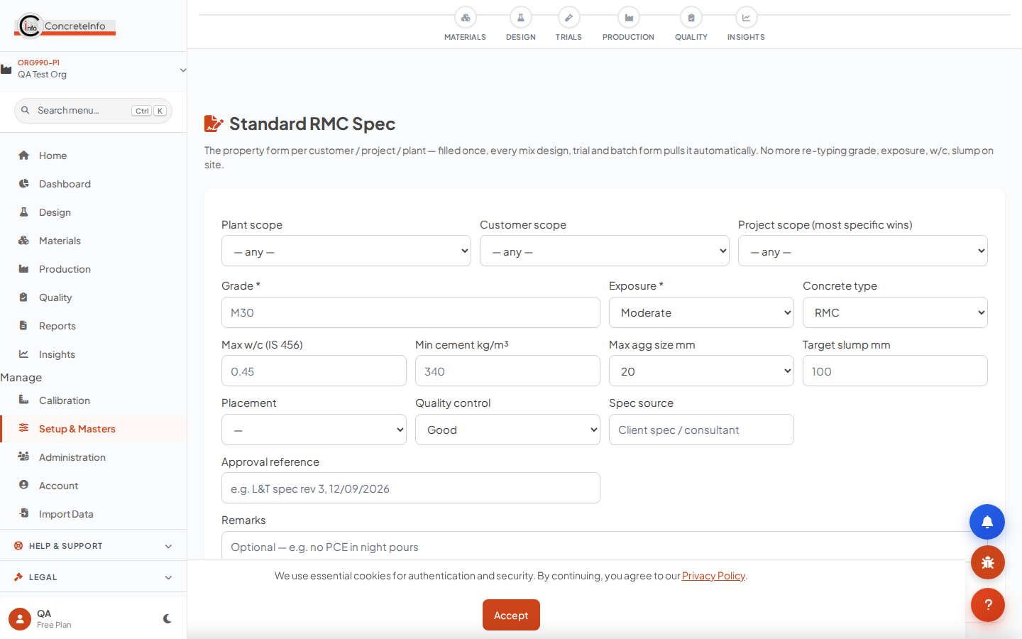
RMC Spec: scope (project > customer > plant), IS 456 one-tap fill, saved specs list.
1. Open RMC Spec (sidebar → Setup). Choose scope: a specific project, a customer, or plant-wide.
2. Tap Fill from IS 456 — Table 5 durability limits (max w/c, min cement) load from the exposure condition.
3. Save. The chip in every calculator confirms what was pulled, with an edit spec link.
💡 Resolution precedence is project → customer → plant. Selecting a customer/project on any calculator pulls the matching spec instantly — no retyping.

Creating a Mix Design — IS 10262 Five-Section Flow
The primary design path (IS 10262:2019): Section 1 inputs, Sections 2–4 calculations, Section 5 final proportions — saved as a design you can trial, batch and pour against.
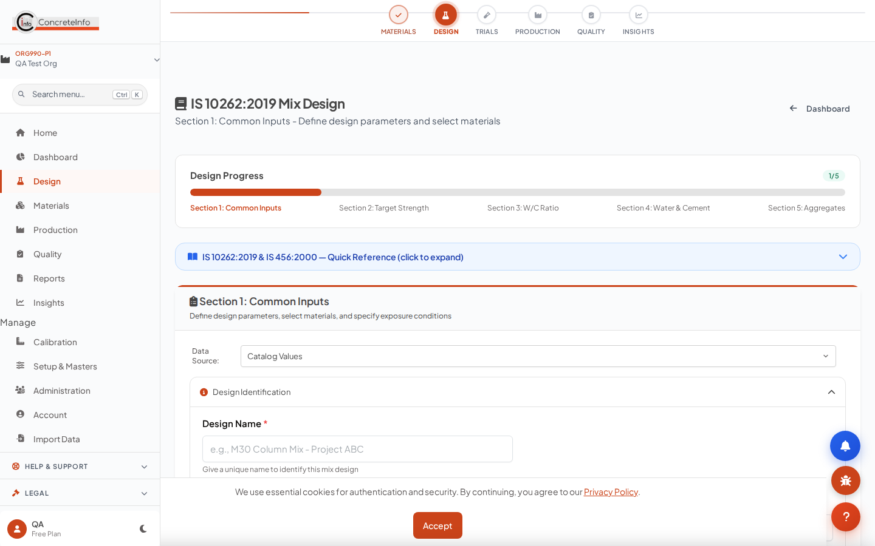
Section 1: target grade, exposure, materials — with the RMC spec already pulled.
1. Pick the client and project — the spec chip confirms the pulled specification.
2. Enter target strength, exposure, aggregate sizes, admixtures; materials come from your library.
3. Walk through Sections 2–5; each section carries forward automatically.
4. Save — the design appears in My Designs with the client/project recorded.

Other Calculators (ACI, BRMCA, EFNARC SCC, HSC, Enhanced IS 10262)
Every method is available on every paid plan. All of them auto-pull the RMC spec and save the customer/project with the design.
Calculator hub: IS 10262, ACI 211, BRMCA/DoE, EFNARC SCC, HSC, UHPC and more.
Method | Best for | Spec pull
ACI 211.1 | US-practice mixes (psi inputs) | MPa → psi, mm → inch bands
BRMCA / DoE | UK-practice mixes | MPa cube → cylinder class (C25…C55)
EFNARC SCC | Self-compacting concrete | Target strength direct
HSC | M60–M100 high strength | Grade + slump + exposure
IS 10262 Enhanced | Full control, SCM blends, ice | Full parameter set

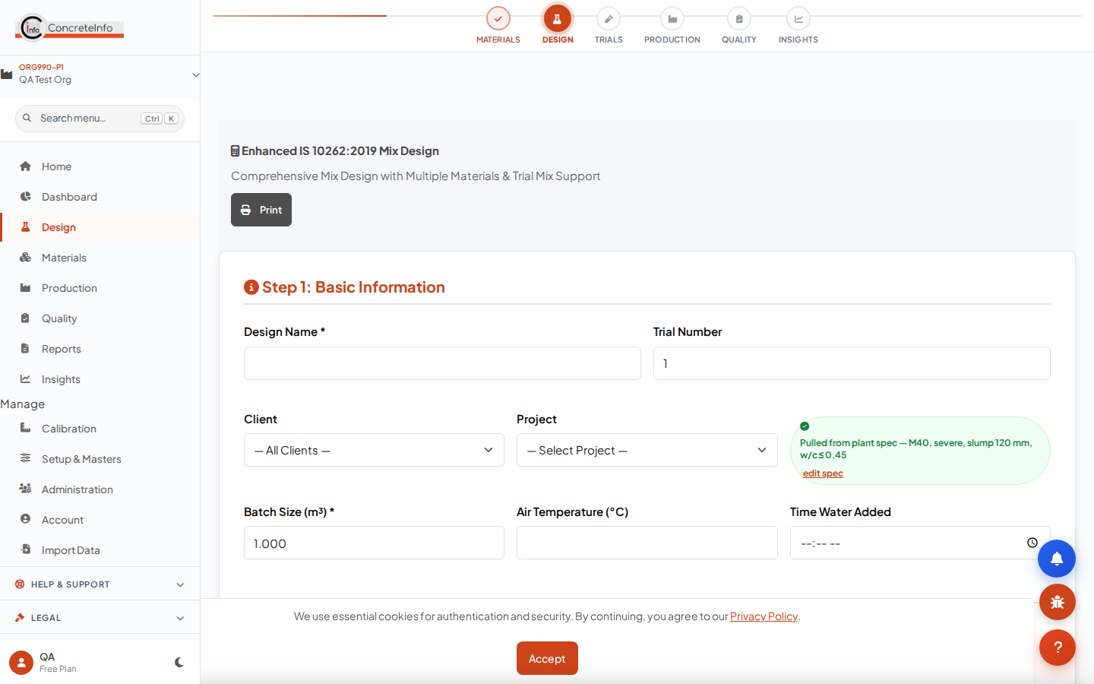
Enhanced calculator: multi-aggregate rows, linked field sample support.
💡 Units are converted safely: a spec saved in MPa fills an ACI psi field correctly (×145.04), and a select is never set to a value its list does not contain.

Managing Your Designs
My Designs lists every design with its client and project; View Design shows the full proportions, materials and compliance.
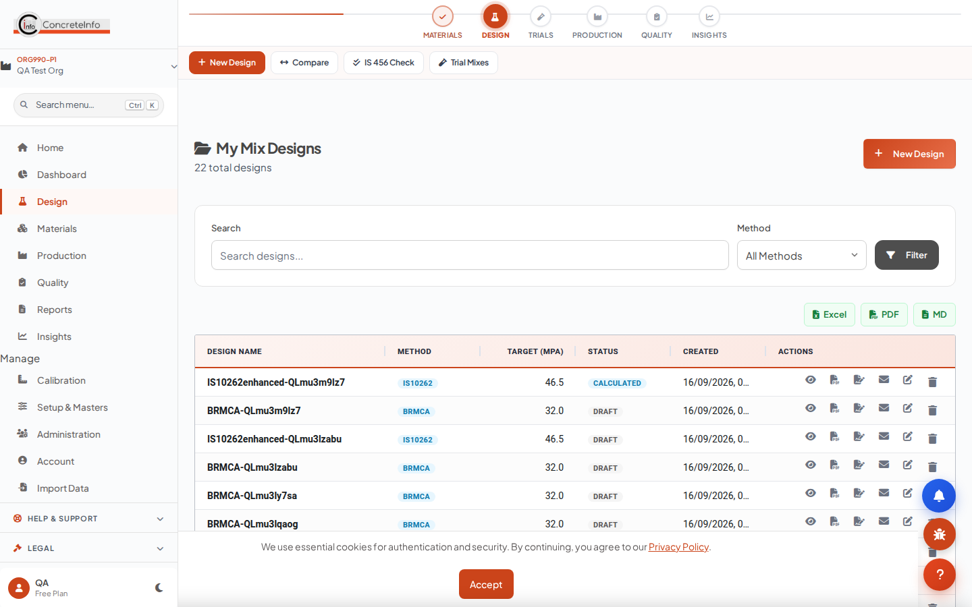
My Designs — client · project shown under every mix.
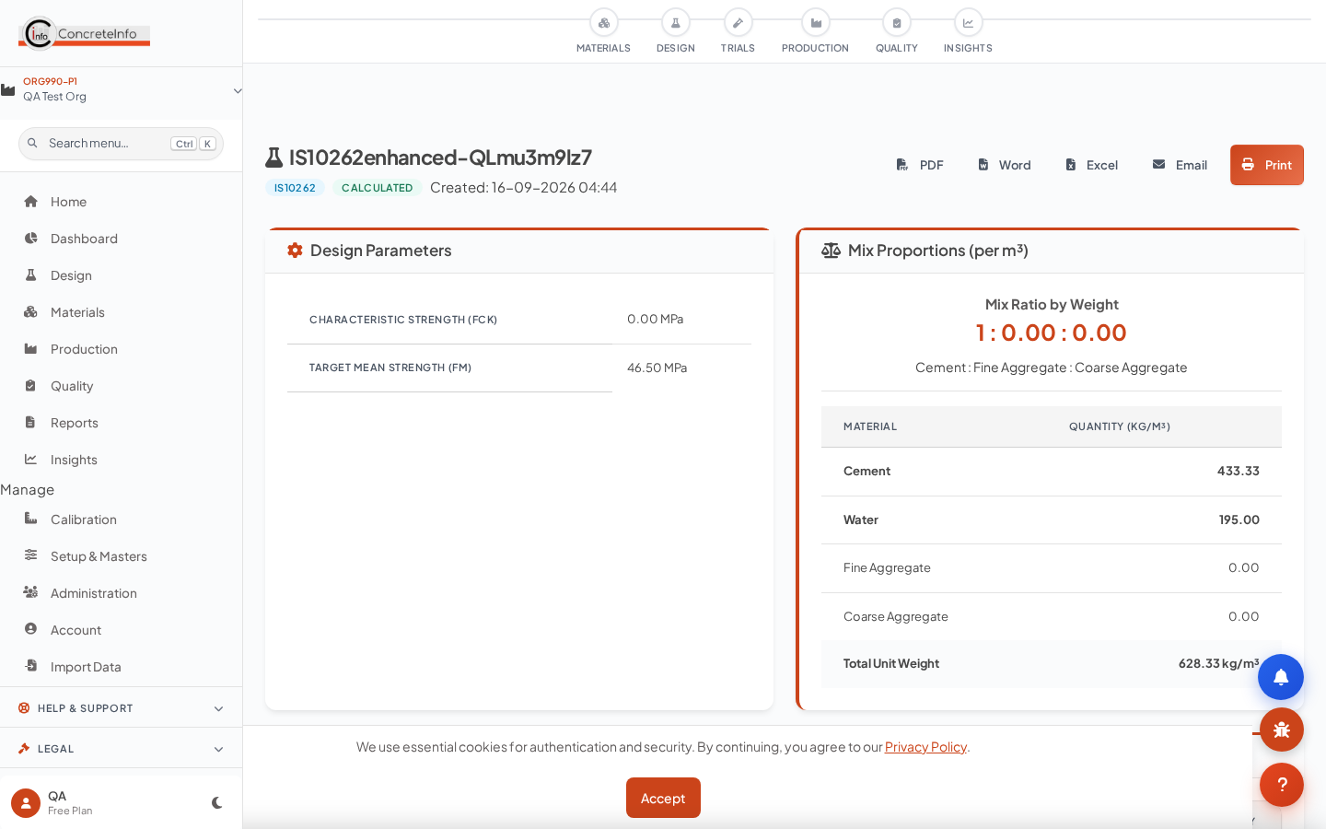
View Design: proportions, project info with client and site address.
1. Search by mix name, client or project.
2. Open a design to view proportions, print, or export the submittal.
3. Draft designs become Calculated / Verified / Approved as you progress — quality tests list non-draft designs.

Materials Library
Cements, SCMs, aggregates, admixtures, fibres and water — one library feeding every design, ticket and test.
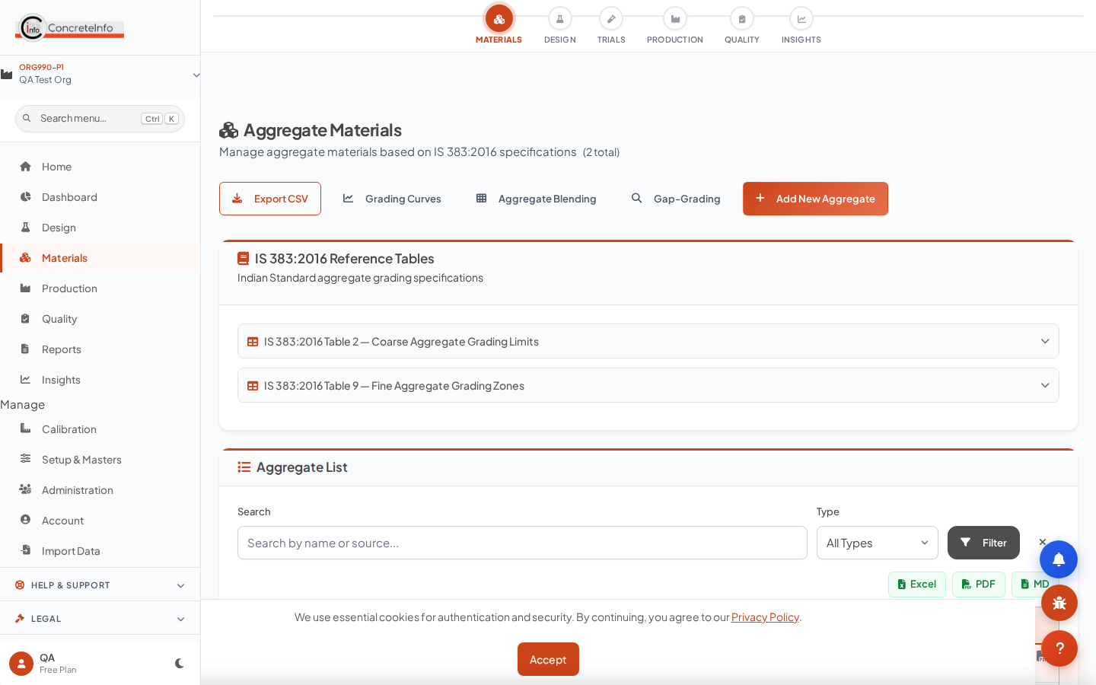
Aggregates: source field with supplier lookup chip.
1. Add a material with its properties (SG, FM, grading, moisture).
2. Type a known supplier — their contact/GST card appears and the last-used source fills in.
3. Upload a supplier test certificate (PDF/photo) — OCR extracts grading and properties for review.

Batch Tickets
Generate a ticket from a pour: the design multiplies by volume, the plant and materials cascade in, and a QR links the ticket to the pour.
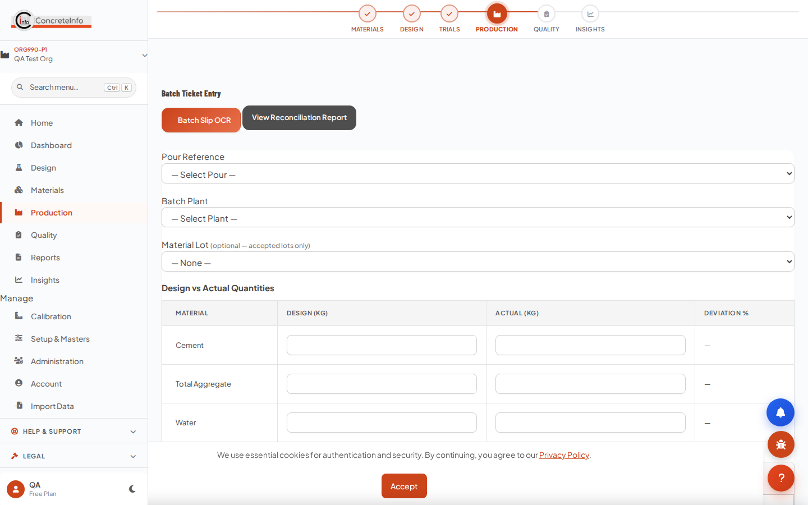
Batch ticket: pour cascade chips, per-m³ design × volume.
1. Select the pour — client, project and design fill automatically.
2. Enter the batch volume; quantities recalculate from the design.
3. Print or share the ticket; scanned copies feed the pour record.

Pour Register
Every pour is the anchor for its tickets, field samples, fresh tests and cubes — one pour card binds the whole trail.
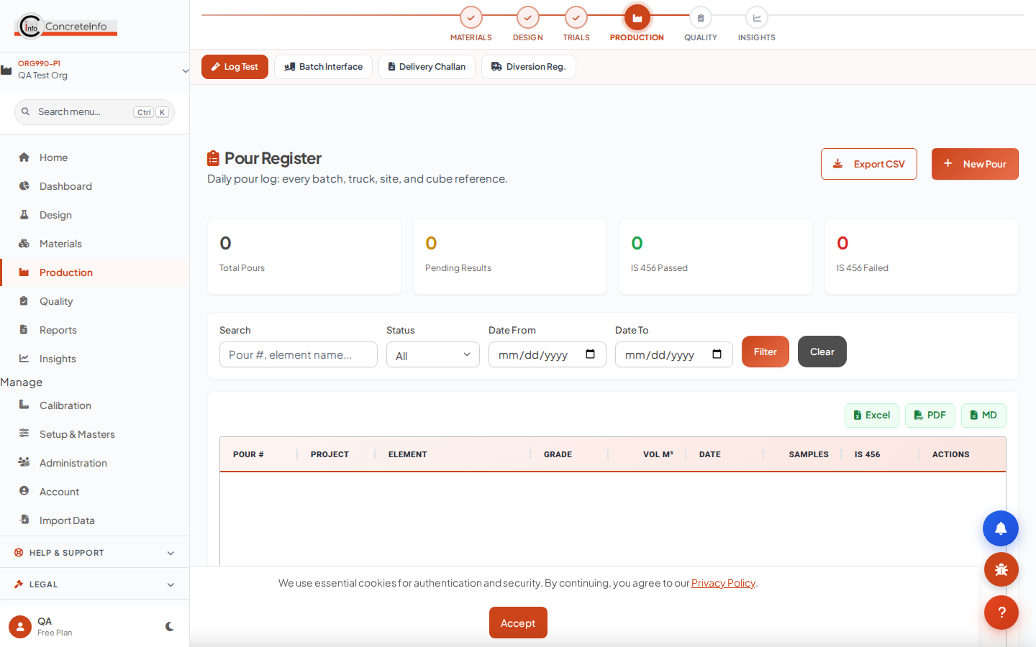
Pour register: structural element, grade, volume, status.
1. Create the pour (or let the ticket create it) — grade and mix reference come from the design.
2. Everything downstream links by pour: sampling, fresh tests, cube sets, pour cards.
3. The pour card carries GPS, weather, signatures and photos from the field.

Field Sampling & Fresh Tests
Register the field sample, test fresh properties at the point of placement — slump, temperature, air, density — with weather and GPS captured automatically.
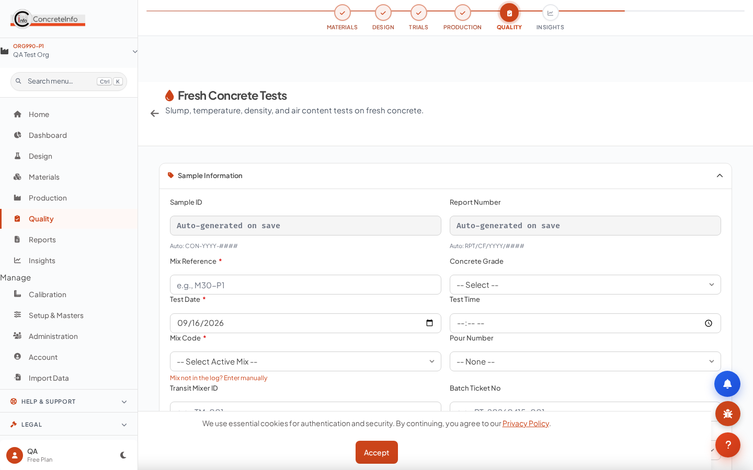
Fresh test: project cascade, sample ID, slump/air/density.
1. Pick the pour — mix reference and location cascade in.
2. Record fresh properties; the sample ID (SMP-…) is generated for you.
3. Cube sets cast at sampling inherit everything.
💡 The fresh test record is the head of the hardened trail — its values reappear on every downstream test.

Cube Casting
Cast cube sets from the field sample — slump, temperature, air and density prefill from the fresh test, cast date from the pour.
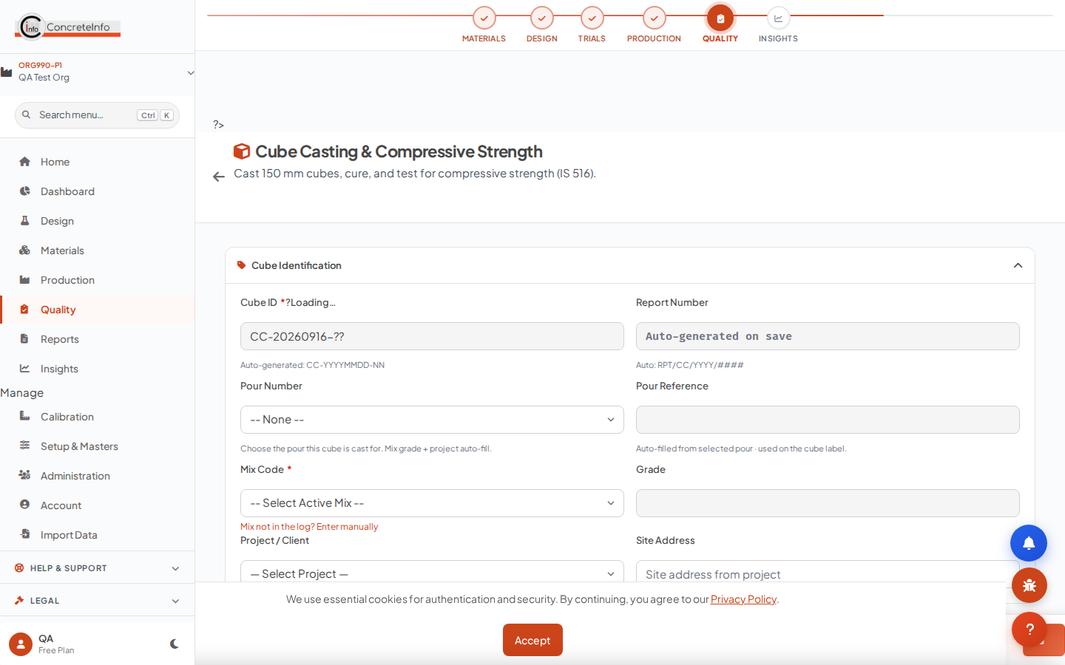
Cube casting: prefilled fresh properties chip, set/cube details.
1. Select the pour/sample — the prefill chip shows what was pulled.
2. Enter cube count and test ages (7/28/56/90 days as required).
3. Curing tank and cube IDs are tracked; the compressive test picks them up by age.

Hardened Tests — Compressive, Flexural, Split, Core, NDT
Link the field sample once and the whole context follows: client, project, mix, cast date — plus the fresh properties at casting, echoed on the report.
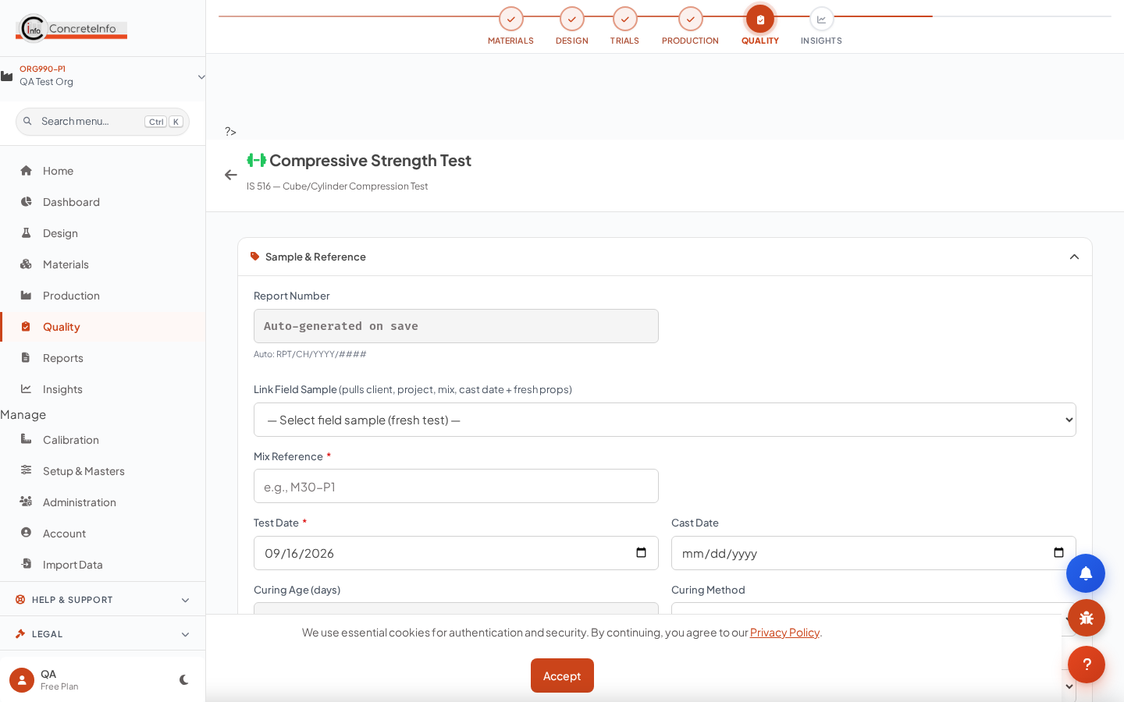
Compressive test: Link Field Sample cascade + fresh-at-casting chip.
1. Open the test page and pick the sample from Link Field Sample — client, project, site, mix reference, grade and cast date all fill.
2. The green chip shows the fresh properties at casting (slump, temp, air, density) for correlation.
3. Enter failure loads — averages, characteristic strength and IS 456 acceptance criteria evaluate automatically.
4. Upload the CTM worksheet photo — OCR reads the loads into the form for review.
⚠ Editing a saved test never overwrites its original linkage — the sample link is set once, at creation.

Reports & Exports
Every test, design and ticket exports to PDF, Word or Excel; submittals bundle a design with its supporting tests.
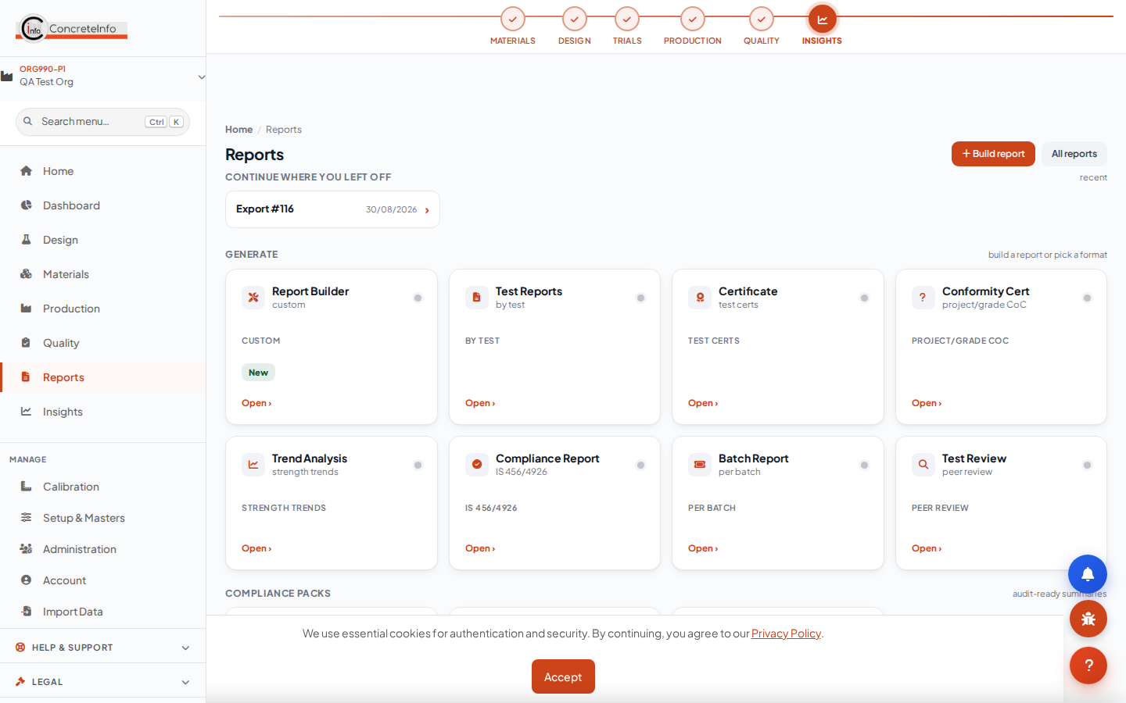
Reports hub: test reports, submittals, registers, analytics.
1. Open any record and use the export buttons, or batch-export from the Reports hub.
2. Reports carry your logo and colours (Branding, available on all paid tiers).
3. Digital signatures and approval status are included on test reports.

Team, Invites & Roles
The first user in an organisation is its Super Admin. Invite teammates by email link — same-domain colleagues are discovered automatically. Each invited user runs their own subscription.
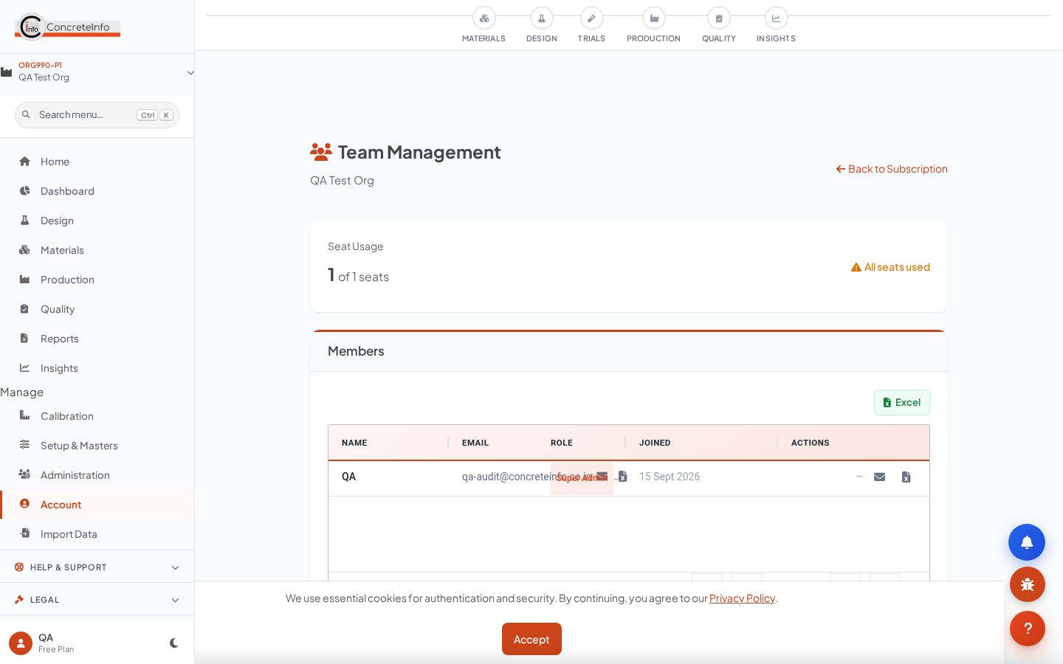
Team page: domain discovery, pending invite links, roles.
1. Open Team (Account) — same-domain candidates appear automatically.
2. Send an invite link (valid 7 days); the invitee signs up straight into your organisation.
3. Assign roles: Super Admin, Manager, Engineer, Technician, Viewer.

End-to-End Workflow
The CMDApp principle: enter once, pull everywhere. The chain below is the whole product — each step hands its data to the next.
Client / Project → RMC Spec → Mix Design → Trial Mix → Batch Ticket → Pour → Field Sample → Fresh Test → Cube Casting → Hardened Tests → Reports.
Stage | Entered once | Pulled downstream
Setup | Client, project, site address | Every form, ticket, report
RMC Spec | Grade, exposure, w/c, slump | All calculators
Mix design | Proportions, materials | Trials, tickets, tolerance checks
Pour | Element, volume, location | Tickets, samples, cubes
Field sample | Fresh props, weather, GPS | Cubes, hardened tests, reports

💡 If you find yourself typing the same value twice anywhere, something is wrong — tell us and we will wire the pull.

FAQ & Troubleshooting
The questions support hears most.
Why is a calculator field already filled?
That is the RMC spec pull — the green chip names the source (plant / customer / project spec) with an edit link. Saving the design keeps those values.
The Link Field Sample dropdown is empty.
It lists the 40 most recent field samples (fresh tests) for your organisation. Cast/log a fresh test first.
I cannot create another plant.
Your tier limit is reached — the meter on My Plants shows usage. Upgrade from the button there or from Subscription.
My design does not appear in quality tests.
Test pages list designs in Calculated / Verified / Approved status. Open the design and mark it calculated first.
Exports print without our logo.
Set it once in Account → Branding (all paid tiers). Report and e-mail footers always carry the standard ConcreteInfo matter.
Login fails after several tries.
The rate limiter locks the account briefly after repeated attempts — wait a few minutes or reset your password.

Glossary
Common terms used across CMDApp.
Term | Meaning
RMC | Ready-Mixed Concrete — batched at a plant, delivered to site.
IS 10262:2019 | Indian Standard concrete mix proportioning guideline.
IS 456:2000 | Indian Standard code of practice for plain and reinforced concrete (Table 5 sets durability limits).
w/c ratio | Water–cement ratio by mass — the primary durability control.
NCR / CAPA | Non-Conformance Report / Corrective & Preventive Action.
CTM | Compression Testing Machine.
SCC | Self-Compacting Concrete (EFNARC classed by slump-flow, T500, V-funnel, L-box).
TMS | Target Mean Strength — characteristic strength plus statistical margin (1.65 × s).
Spec default | The standard RMC property form saved per plant / customer / project.

